**Collect the Dataset:**

Data contains all the meta information regarding the columns described in the CSV files. we have provided two CSV file:

* athlete_events.csv
* noc_regions.csv

use the link to download the dataset:  [**Link**](https://www.kaggle.com/datasets/heesoo37/120-years-of-olympic-history-athletes-and-results)

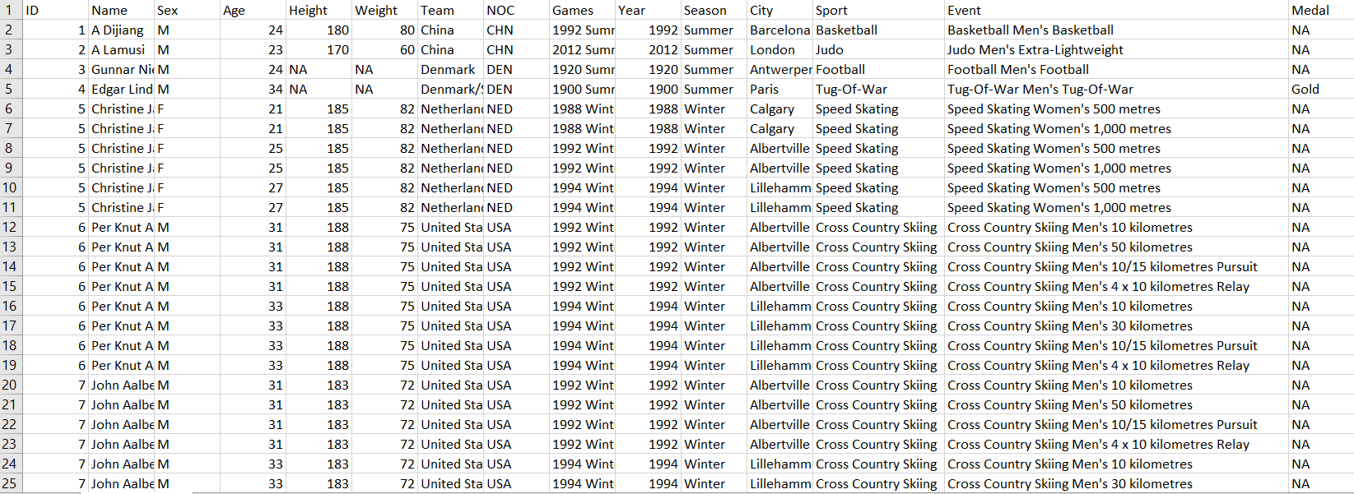**athlete_events.csv :**

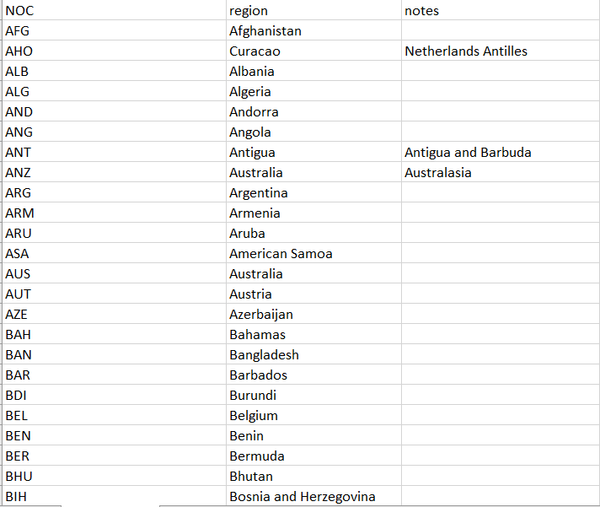**noc_regions.csv :**

**Data Preparation :**

Custom tables:

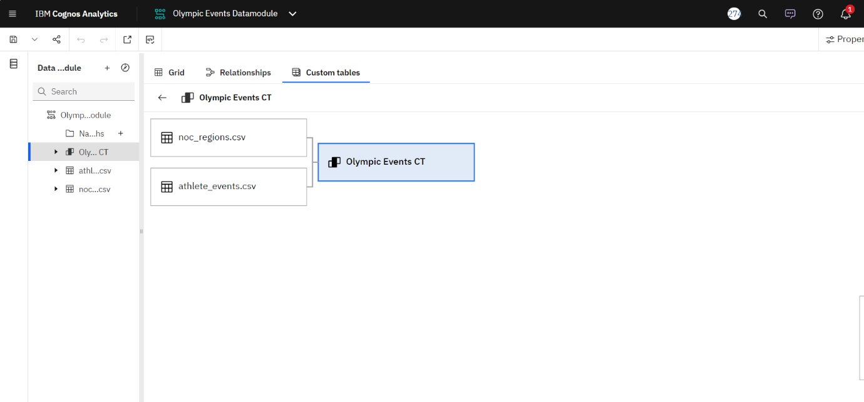

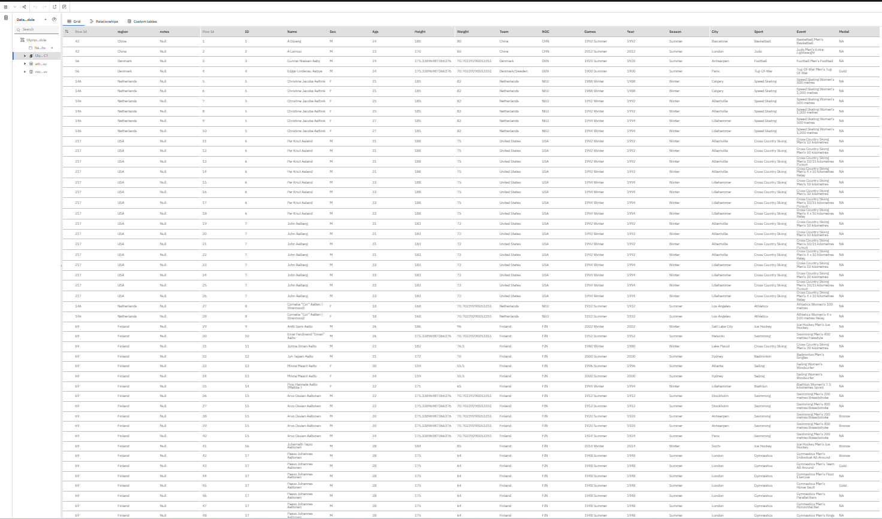 Grid:

**Data Visualizations :**

No Of Medals Won By Year :

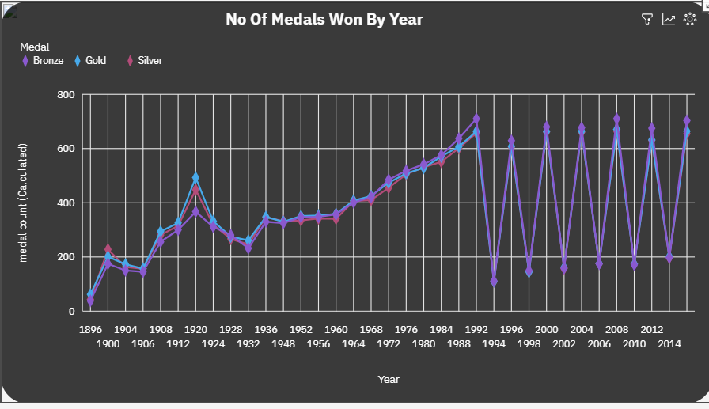

No Of Medals Won By Countries :

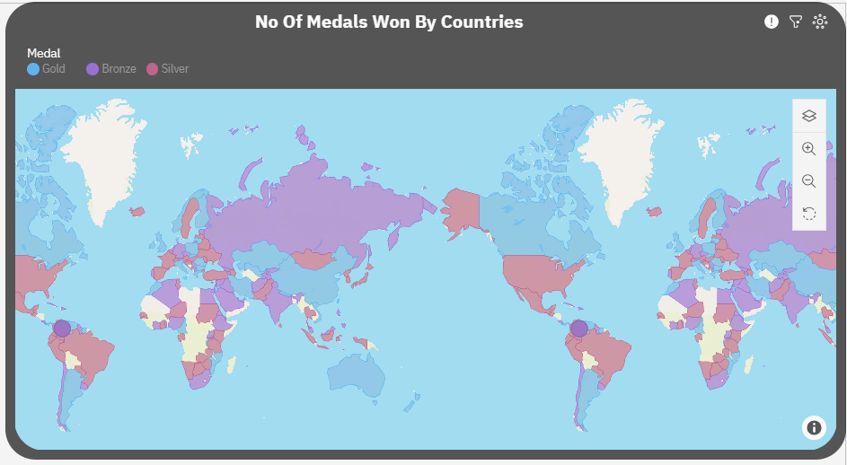

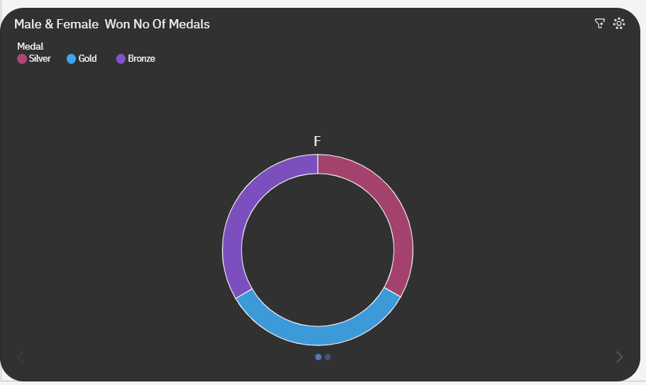 Female Won No Of Medals :

Male Won No O f Medals :

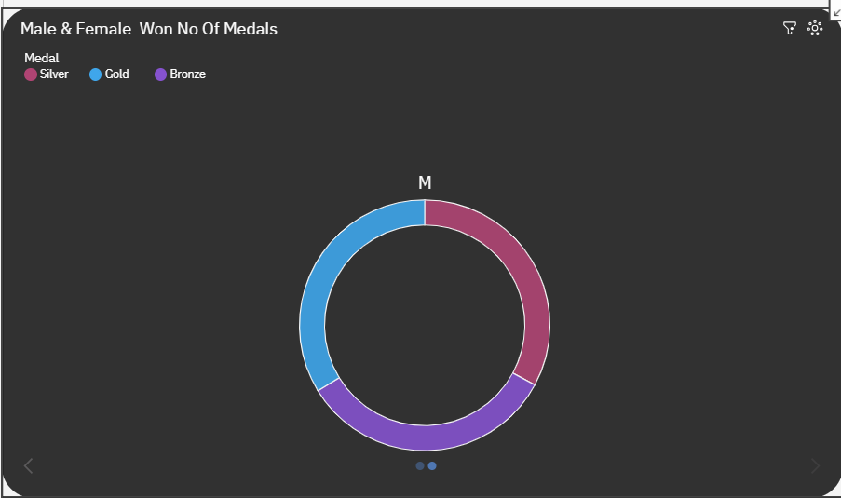

No Of Medals Won By Players :

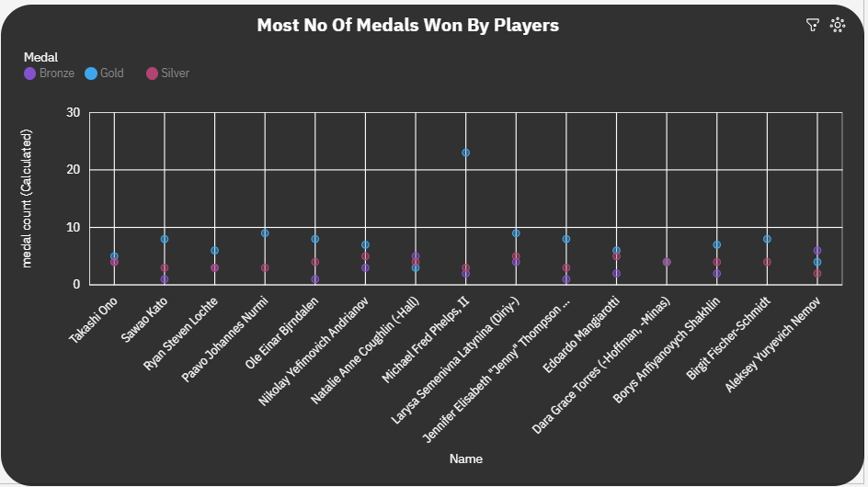

Top 3 Female Won Most No Of Medals :

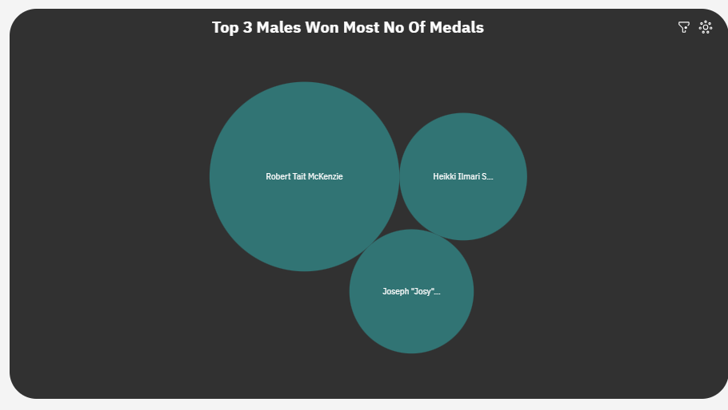Top 3 Male Won Most No Of Medals :

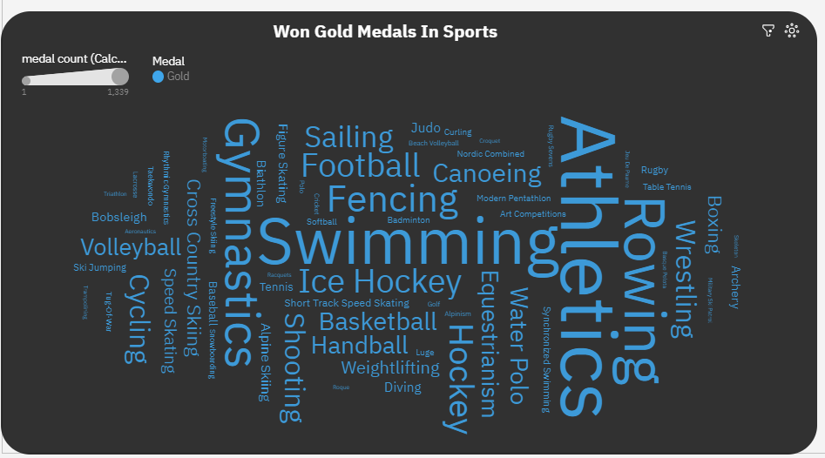Won Gold Medals In Sports :

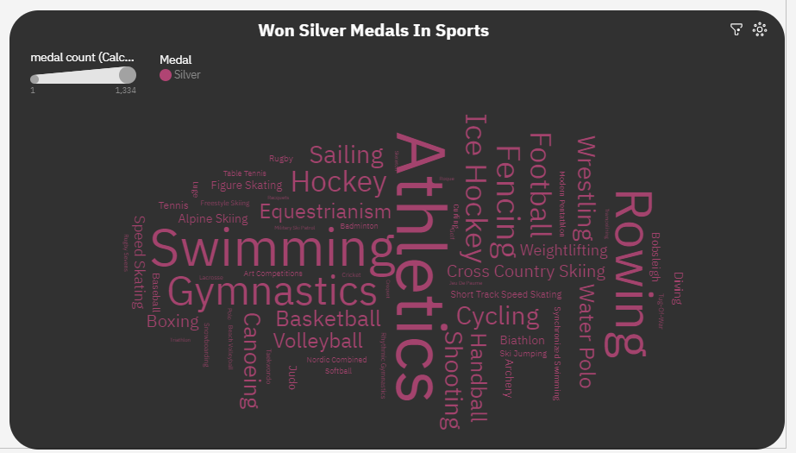Won Silver Medals In Sports :

Male & Female Players Average Age & Height In Centimeter :

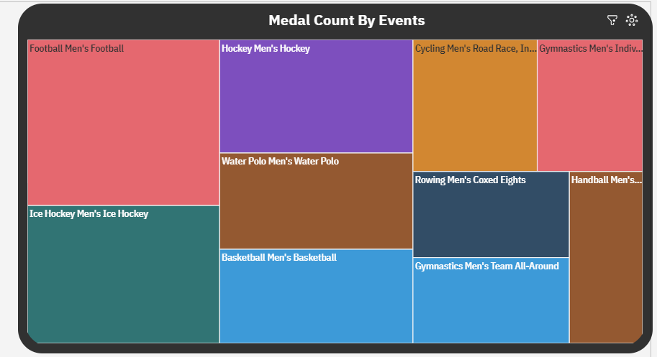Medal Count By Events :

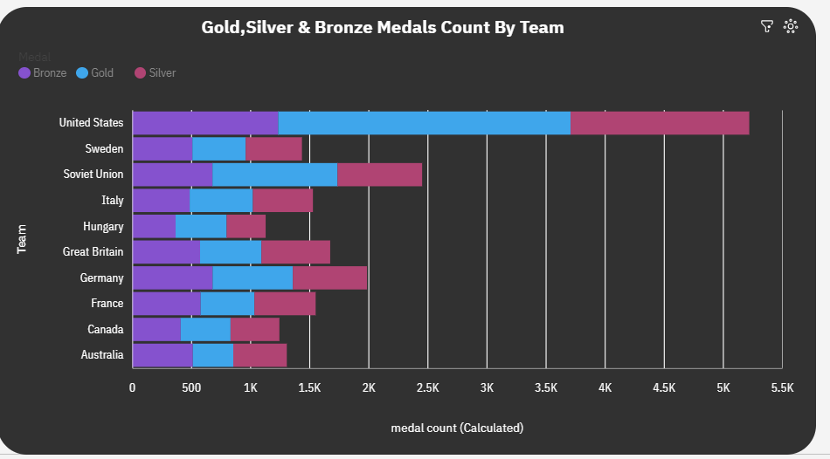Gold,Silver & Bronze Medals Count By Team :

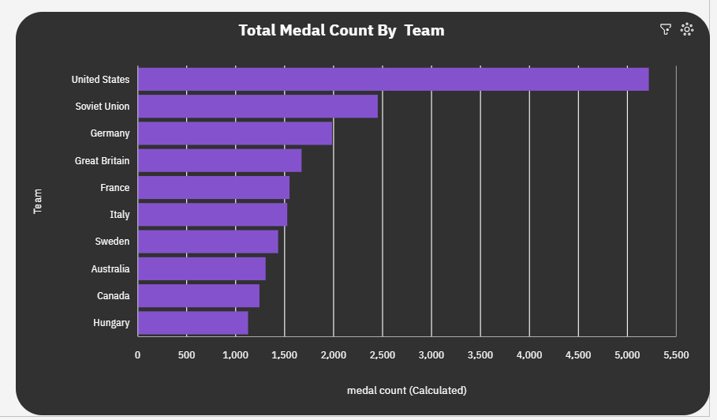Total Medals Count By Team :

The above Data visualization is the process of creating graphical representations of data in order to help people understand and explore the information. The goal of data visualization is to make complex data sets more accessible, intuitive, and easier to interpret. By using visual elements such as charts, graphs, and maps, data visualizations can help people quickly identify patterns, trends, and outliers in the data.